CARGO HOLDS AND HATCHES

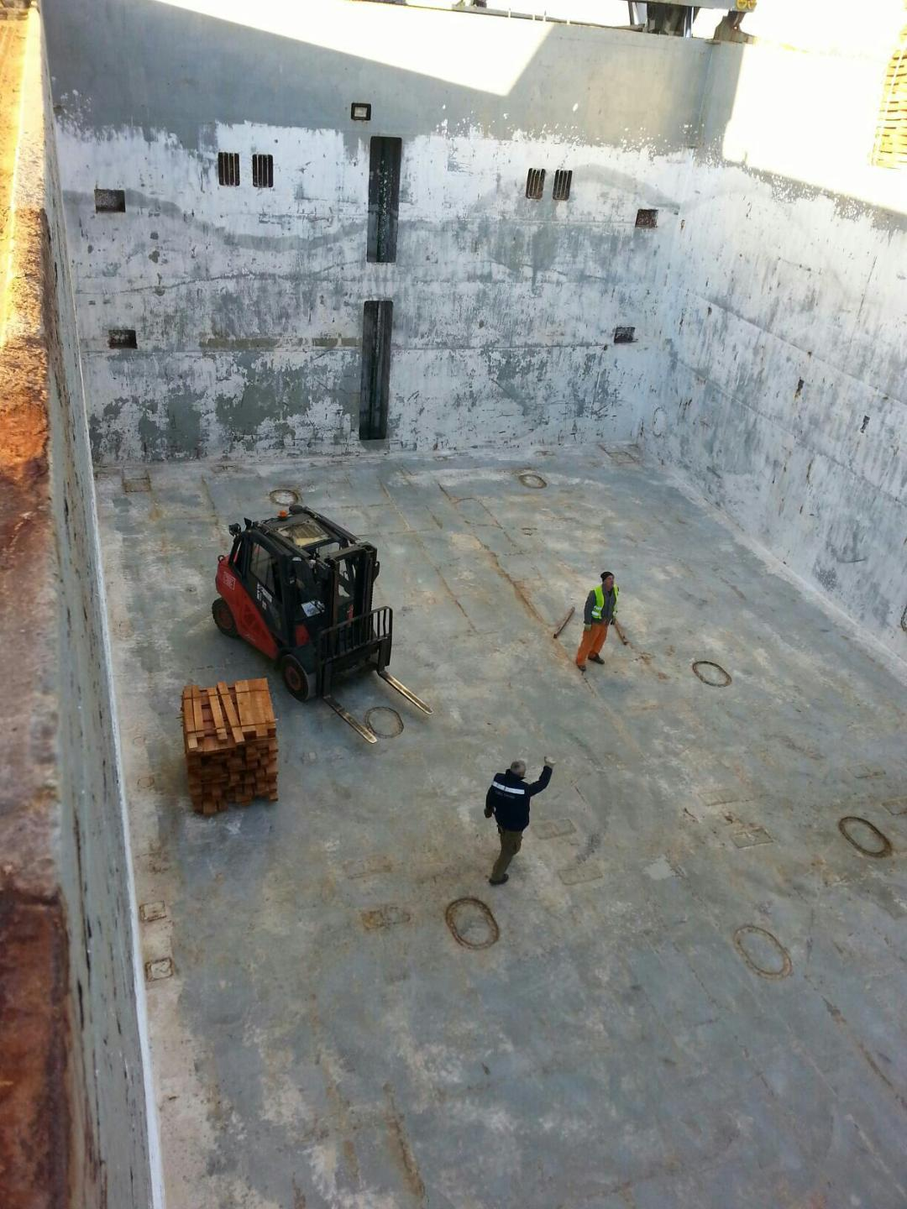

BOX SHAPED CARGO HOLD

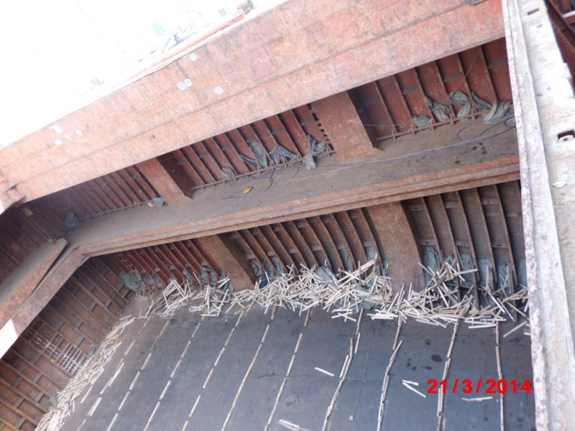

CARGO HOLD OF TWEENDECKER JUST DISCHARGED (UNCLEANED FOR NEXT CARGO)

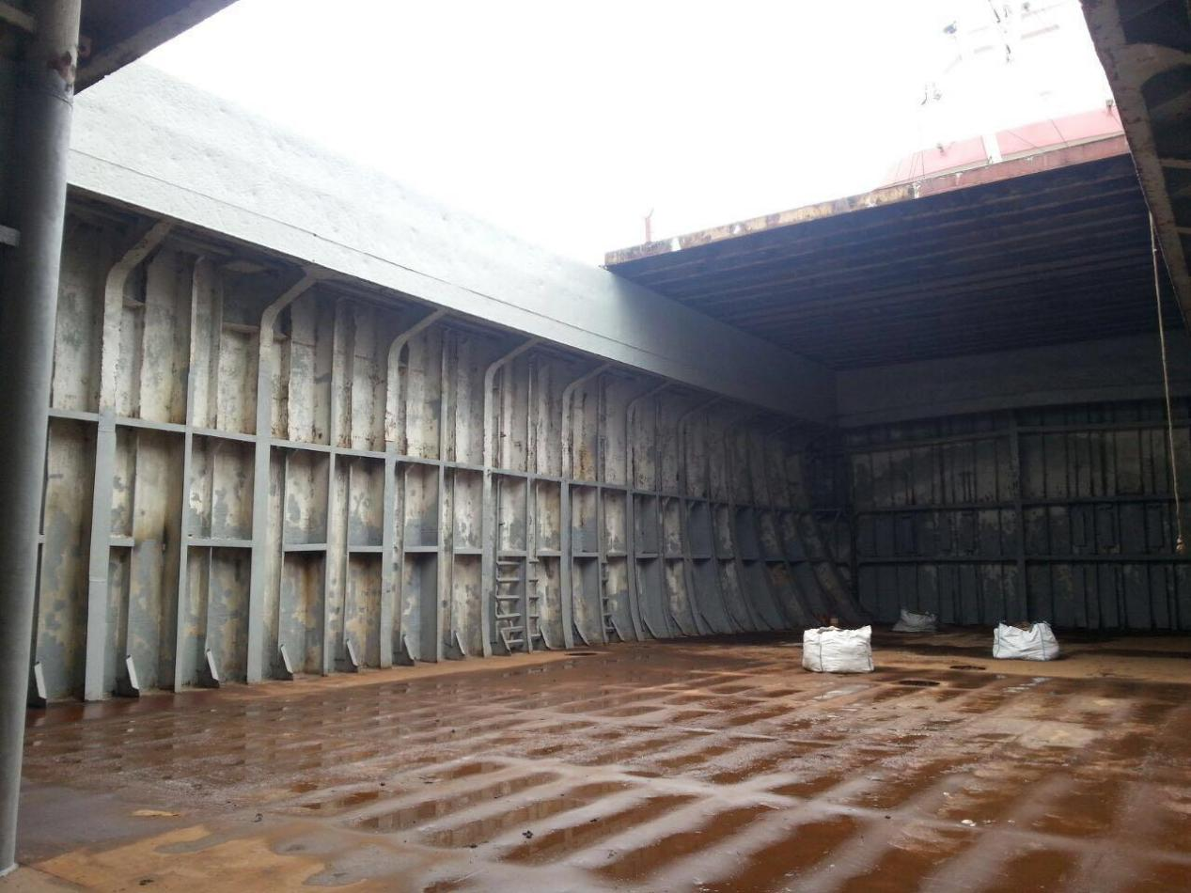

CARGO HOLD OF A SINGLE DECKER - FRAMES ARE VISIBLE


FOLDING TYPE HATCH COVERS

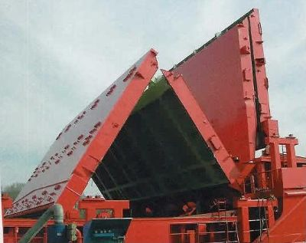
FOLDING TYPE HATCH COVERS



SIDE-ROLLING TYPE HATCH COVERS

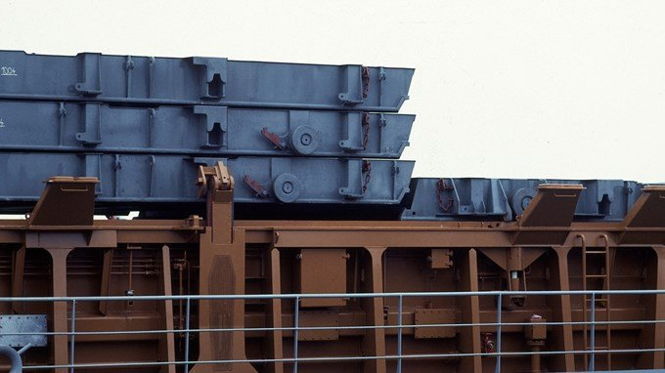

Stacking hatch covers

