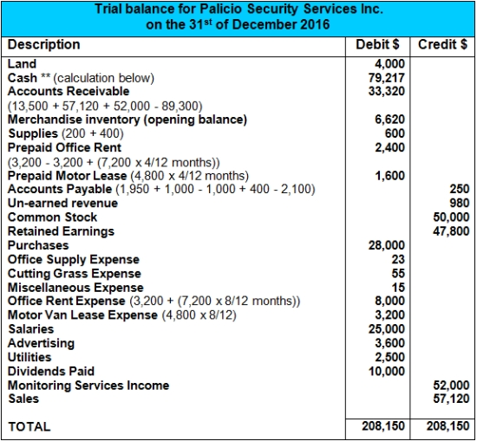
Notes:
** Cash includes $100 petty cash. Calculation of cash balance:
74,210 - 1,000 - 4,800 - 7,200 - 28,000 - 2,100 - (100 - 7) - 25,000 + 89,300 - 3,600 - 2,500 - 10,000
= 79,217
The opening balance of prepaid rent ($3,200) has been expensed out during 2016 as we have assumed this rent (that was paid the previous year) applies to the 2016 year. This is a likely assumption as there was a new prepaid rent cash payment on 2 May, 2016.
It is not stated in the question whether the unearned revenue of $980 at the beginning of 2016 was actually earned during the year. In this solution we have assumed that the unearned revenue still remains unearned at the end of 2016. However, it is quite acceptable to treat this as having been earned during 2016. If treating it as earned during 2016 one would add $980 to revenue and remove the unearned revenue account ($980 - $980).

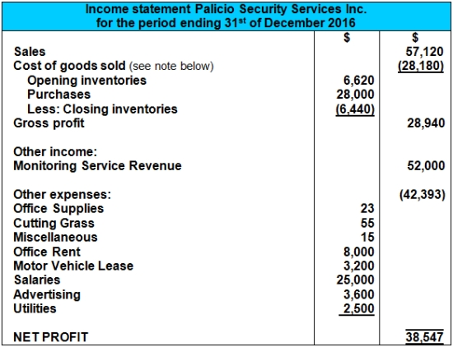

Calculation of Cost of Sales and Closing Inventory (FIFO Basis):
Opening Balance of Merchandise Inv. (24 Units @ $265 + 1 Unit @ $260) $6,620
Purchased during the year 100 Units @ $280 $28,000
Total available for sale 124 + 1 Units (125 Units) $34,620
Sold*(Cost of Sales) 102 Units $28,180
Closing Balance of Merchandise Inv. 23 Units @ $280 $6,440
*Cost of Sales 102 Units (24 Units @ $265) + (1 Unit @ $260) + (77 Units @ $280) = $28,180
