HOW TO LOAD AND DISCHARGE A SHIP

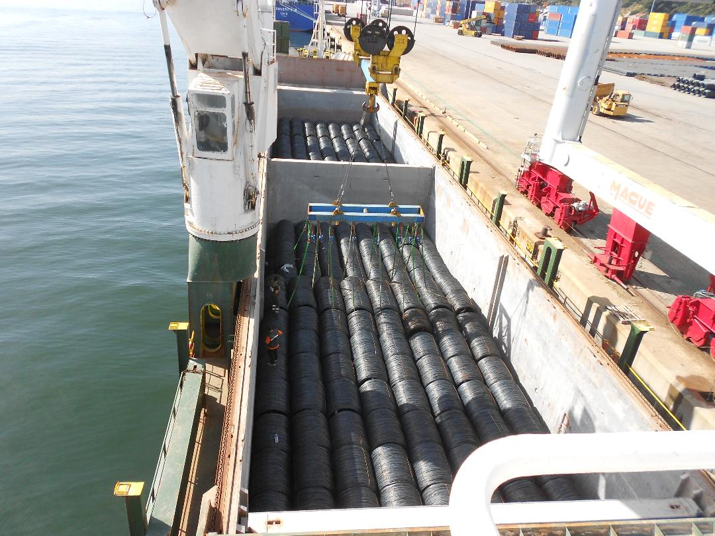

WIRE RODS LOADING BY SHORE CRANE
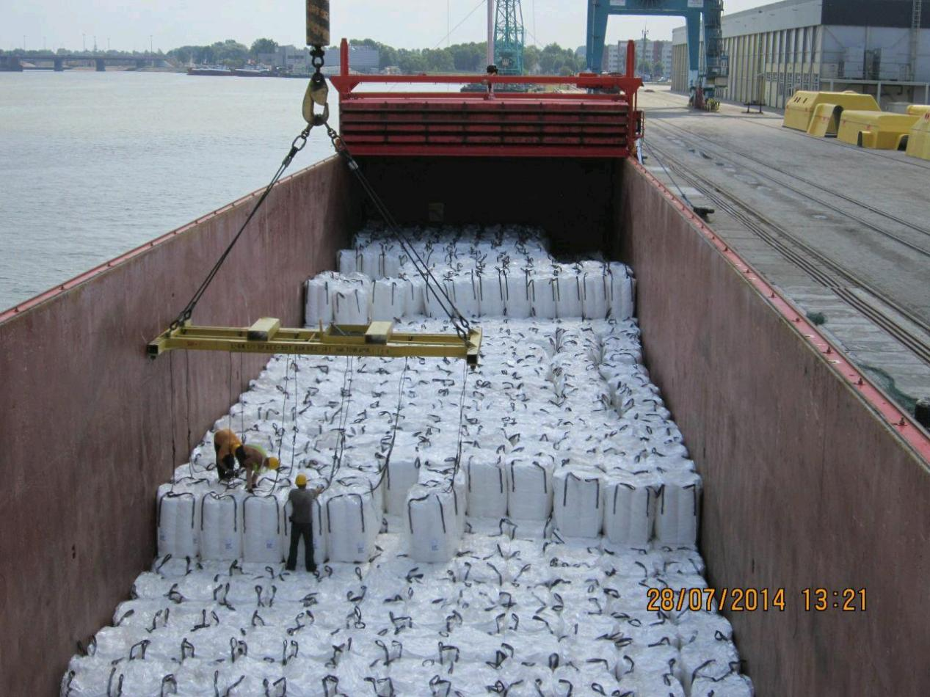
“BIG BAGS” LOADING IN A BOX SHAPED CARGO HOLD

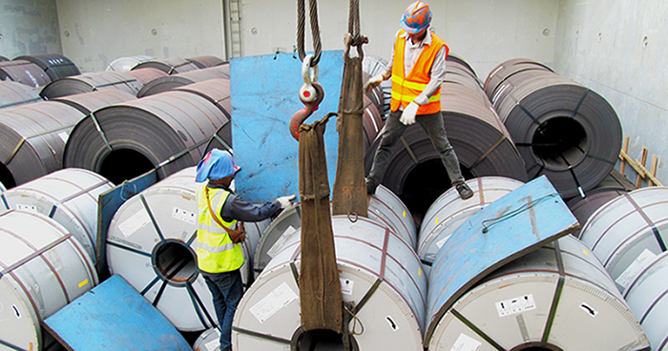
HEAVY STEEL COILS LOADING

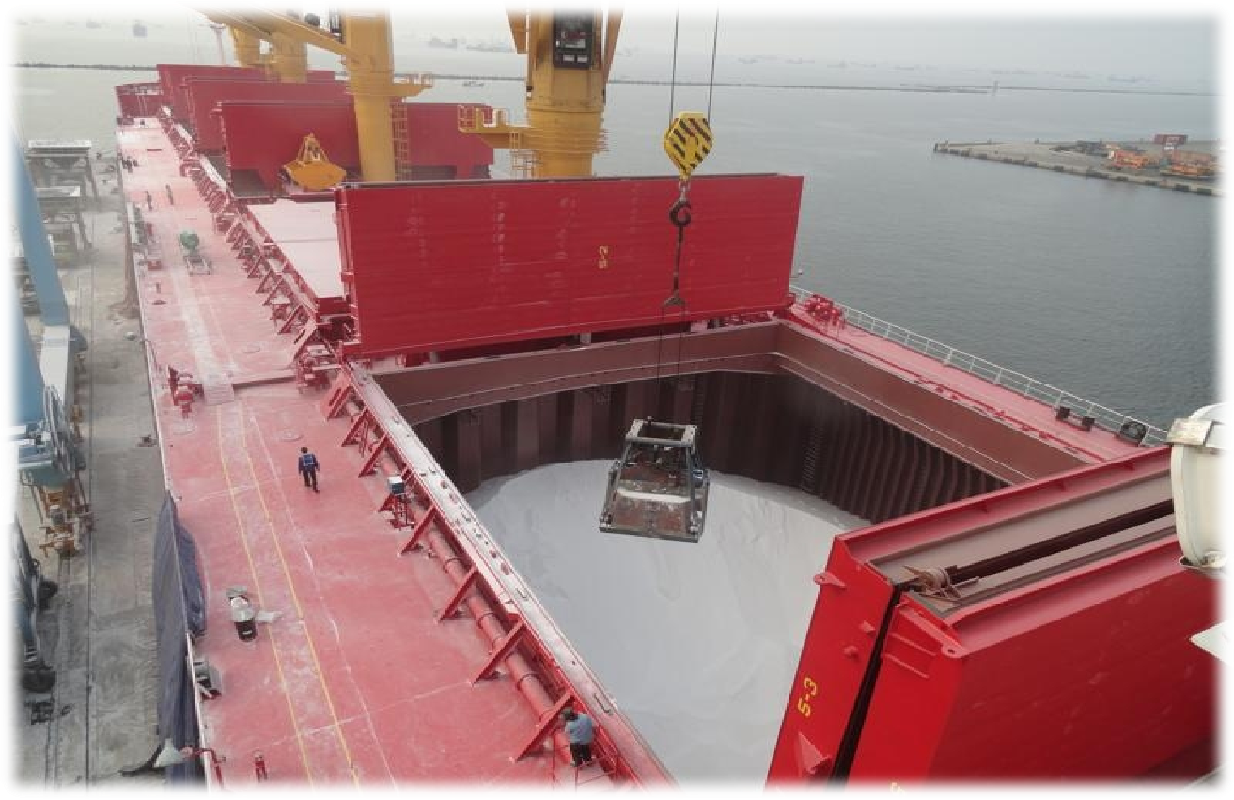
DISCHARGING BULK CARGO BY GRAB (FERTILIZER ?)

GRAIN CARGOES LOADING AND DISCHARGING

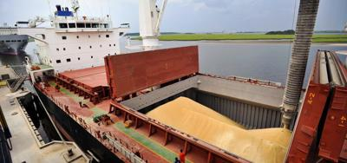
BULK WHEAT LOADING

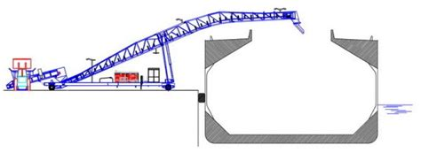

MOVABLE BULK GRAIN LOADER (USUALLY LOW RATE)

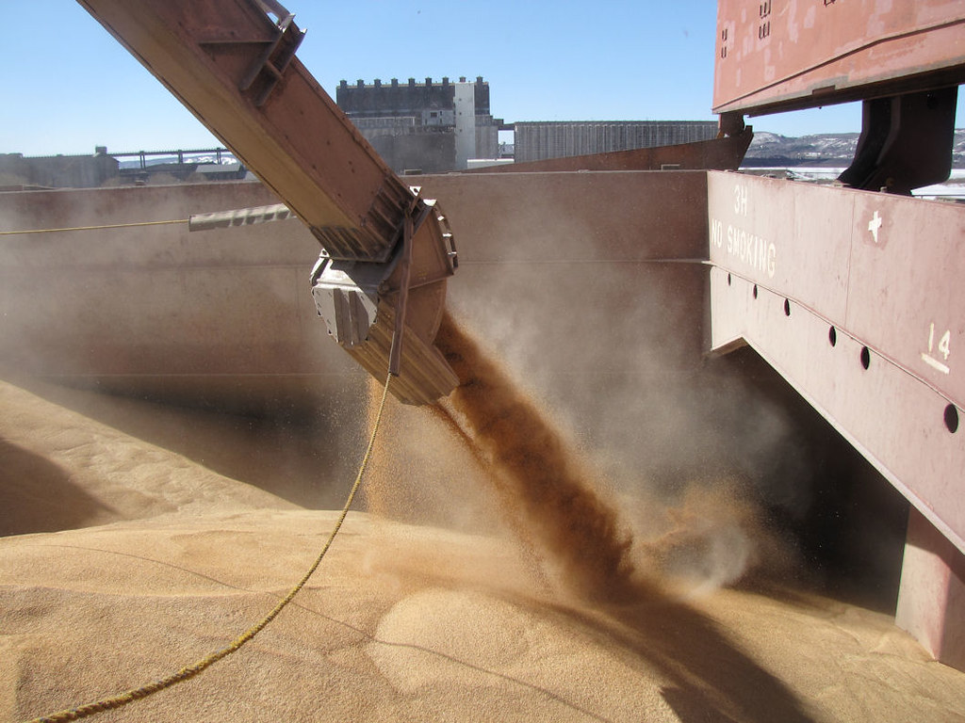

HIGH RATE BULK WHEAT LOADING (SPOUT TRIMMING)


FLEXIBLE LOADING EQUIPMENTS FOR BULK GRAIN CARGOES

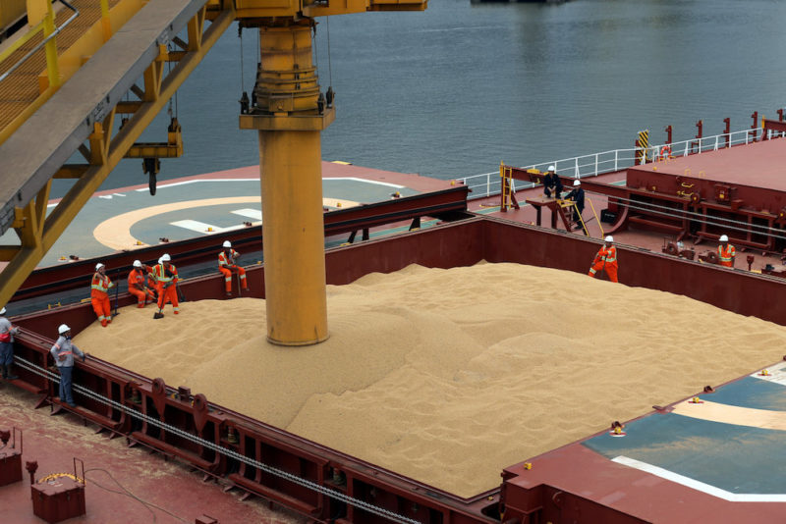

HIGH RATE BULK WHEAT DISCHARGE

